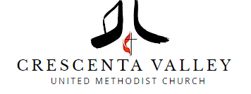
Crescenta Valley United Methodist Church. These are the mask requirements that we will be implementing for all in-person activities at the church starting Sunday March 13th.
We are following Best Practices in implementing this policy.
1. All fully vaccinated congregants, guests, and staff can choose whether or not to wear a mask indoors. We highly recommend that immunocompromised individuals continue to mask indoors. Partially vaccinated or non-vaccinated persons must continue to wear a well-fitting mask indoors. We ask that you continue to respect physical boundaries and a fully vaccinated individual’s choice to mask.
2. "Fully vaccinated" is now defined as having received a first round of vaccination (two shots for Pfizer and Moderna or one shot for Johnson & Johnson) AND having a booster, as recommended/eligible. The booster shot needs to be at least two weeks before the activity.
3. We will now require proof of full vaccination for Covid-19 upon entry for anyone 5 and older, either by showing digital proof (either photo of your card or digital card) or your hard copy of your vaccination card (please plan to arrive early to check in). We will keep track that you are vaccinated and you only will need to show it one time. .
4. Children age 2 years to 5 years will still be required to wear a mask since they cannot be vaccinated.
5. Montrose Preschool & Infant Care Center has a separate policy.
.We want to thank you all for following these requirements to keep everyone safe and healthy.
Rev Denyse and your Leadership Team

